Intermediate report – Greece

September 2022
Partner: Second Tree and Municipality of Ioannina

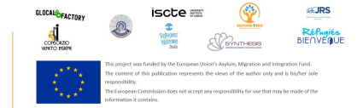
WP7
Intermediate report
Country: Greece
Partner: Second Tree and Municipality of Ioannina
Date of the intermediate report: September 30, 2022
1 Context

1.1 Asylum seekers, refugees, and other people under international protection: brief description of the national and local situation
As a migrant receiving country, Greece is hosting approximately 119,000 refugees and 37,000 asylum seekers (UNHCR, 2022). In the first half of 2022, Greece has seen the arrival of 9,608 asylum seekers, of which a slight majority of 5,326 people arrived via land. Asylum seekers arrive primarily from Afghanistan, Syria and Pakistan (UNHCR, 2022). Most asylum claims are filed in the Attica region, followed by the Eastern Aegean Islands. A total of 8,534 asylum seekers are waiting for their asylum interview to be scheduled (Refugee Support Aegean, 2022).
Since the start of the war between Russia and Ukraine in February 2022, almost 47,700 Ukrainians arrived in Greece; 16,519 have received temporary protection and 16,688 have registered their asylum application (UNHCR, 2022). Contrary to refugees from other countries, Ukrainians are part of a national integration strategy to stimulate their integration into Greece.
Finally, Second Tree and the Municipality of Ioannina (MoI) operate in Ioannina, located in the Epirus region of Northern Greece. Approximately 4,000 refugees (last updated data from June 2021) live in this area, accommodated in the urban area of Ioannina and two refugee camps: Katsikas and Agia Eleni. Both camps are located on the outskirts of Ioannina, secluded from the local community. Agia Eleni has a site capacity of 463 people. In March 2022, the occupancy was 176 people, of which 45% were children. Katsikas has a site capacity of 1,152 people. In March 2022, the occupancy was 667 people, of which 46% were children (IOM, 2022a). Additionally, 700 refugees and asylum seekers are living in apartments in Ioannina, supported by the ESTIA programme (the Emergency Integration and Accommodation programme of the UNHCR) (Tramountanis et al., 2022).
1.2 Local initiatives and other information worth mentioning towards asylum seekers and refugees’ group

Second Tree EU funded projects
Apart from RaCIP, Second Tree is participating in two other EU funded projects that support refugee’s integration into the local community.
First, the MoI is a partner in the “Empowering Migrants to Be Representative Actors in Community Engagement” (EMBRACE) project, led by Second Tree. This project is funded by the Asylum Migration and Integration Fund (AMIF). The aim is to improve interactions between newcomers and local authorities by equipping policymakers with skills to connect with newcomers;
concurrently the project aims to build the newcomer's know-how to engage in local decision-making processes that impact their daily lives.
Second, Second Tree is participating in the “Translation of Cultural Language for the inclusion of migrants” (TOCL) project. This project is funded by Erasmus + and created based on the need for cultural education for the effective social inclusion of refugees. TOCL was created to teach the host countries' culture to refugees while addressing their language knowledge using an approach called Translating Culture (TC). It aims to make host countries’ cultures accessible to refugees to promote their inclusion and integration. Language teachers will teach culture through the translation of materials such as literature, song lyrics, jokes, proverbs, idioms, newspapers, recipes, anthems, etc.

Second Tree Education Programs
Apart from participation in EU funded projects, Second Tree provides quality education for adults and children in refugee sites across the Epirus region of Northern Greece.
First, our Adult Education programme provides refugees with the only opportunity in the region to develop quality language skills in English. The programme is designed to foster agency and self-reliance, by boosting our students’ communication skills.
Second, our Youth Wellbeing Programme provides children aged 8-16 with a space to develop meaning, routine, and identity in a new context. The programme is modelled on the global scouting movement in its focus on building a shared identity and responsibility towards the world around them. The shared identity has helped overcome ethnic tensions and gender segregation between over twenty ethnicities. Its aim is to give children the confidence, skills, and tools needed to develop intellectually and socially, and ease their integration into their new community.

Projects and initiatives of the Municipality of Ioannina
The MOI has, within its limits of jurisdiction and financial restrictions, established a well-structured protection mechanism in order to provide adequate support to refugees and asylum seekers.
First, the MoI established the “Urban Working Group - UWG”, a coordination mechanism among various humanitarian actors, stakeholders and local authorities to achieve the best possible protection of and assistance to refugees and address their needs in a holistic approach. The UWG was recognized as a good practice by the Intercultural City Programme of the Council of Europe.
Second, the MoI established the Migration and Refugees Integration Council, which records and identifies problems that interfere with the social integration of Third Country Nationals (TCN’s) providing recommendations and proposals for the municipal council aiming to promote the development of local actions facilitating migrant integration.
Third, to provide complementary integration measures (such as language, cultural and vocational classes, information sessions etc.), the MoI has established “The Intercultural Centre for Social Integration “Akadimia”, funded by Open Society Foundation. Recently, this municipal initiative was recognized and presented as good practice, for social inclusion of TCN’s, on the Parliamentary Assembly Committee on Migration, Refugees and Displaced Persons.
Fourth, the MoI participates in the Intercultural Cities Programme of the Council of Europe (ICC) funded to implement the projects: “Intercultural Twinning: Cultural Diversity for Inclusive Growth” targeted local authorities, civic sector organisations, businesses and employers’ associations, chambers of commerce, trade and labour unions, development, youth & migration NGOs, universities and Limassol Intercultural Council. The project aims to develop permanent social dialogue platforms where the diversity is seen as competitive advantage of modern cities; “Mediterranean Intercultural Cities Network: Sport-Youth-Inclusion” aimed to promote tolerance and acceptance of diversity through youth and sport activities.
Fifth, the MoI participated in the Working Group on Intercultural Integration (GT-ADI-INT) which was the first intergovernmental working group on intercultural integration set up by the Committee of Ministers under the Steering Committee on Anti-Discrimination, Diversity and Inclusion (CDADI) to develop a multi-level policy framework for intercultural integration and promoting multi-level dialogue and co-operation between local and national policy makers. The Model Framework for an Intercultural Integration Strategy for the National Level was adopted by CDADI.
Lastly, the MoI participates as a partner in three other AMIF projects, including EPIC, aiming to improve the integration of migrants and refugees into the local community. Moreover, the MoI confirmed the strong commitment on migrants’ integration by signing a bilateral Memorandum of Cooperation with UNHCR and UNICEF, respectively.
Other local initiatives in Ioannina

In Ioannina, there are five other organisations serving refugee populations. Their services range from a makerspace including wood workshops (Habibi.Works), social activities (Youth Centre of Epirus and Be Aware and Share), creative activities (Solidarity Now Orange Centre) and activities for unaccompanied minors (ARSIS).
1.3 Please describe the actions, activities and pilot scheme locally planned under RaCIP Project.
Second Tree
Second Tree is in the early stages of the RaCIP project pilot scheme. Second Tree will hold a kick-off event for the project, as well as group activities to encourage relationship building between mentors and mentees. Following the group activities, the mentorship will continue with individual activities between mentor and mentee.
The pilot scheme’s kick-off event will invite all mentors and mentees. The mentors are Greek families or students who will support young refugees or refugee families living in the area of Ioannina. The aim of the event will be for the mentors and mentees to meet and get to know each other.
The event will take place in a venue familiar to both mentors and mentees to help create a welcoming atmosphere. Drinks and food will be provided, and group activities will be organised. The activities will be games which encourage teamwork, so the mentors and mentees are encouraged to work together. After the event, Second Tree volunteers will collect feedback from all mentors and mentees and create mentor-mentee pairs based on mutual interests.
We have several activities planned to follow the kick-off event. Before the start of the project, we asked the mentors and mentees what kind of activities they would be interested in. Several group activities such as picnics, movie nights, or sports were mentioned. These activities allow the mentor and mentee to get to know each other in an informal setting with the comfort of being around people they already know. Taking their interests into account, Second Tree aims to organise these kinds of group activities on a regular basis, so the mentor and mentee have time to build their relationship with the support of other community members and volunteers. When the mentor and mentee feel comfortable, they are also encouraged to undertake activities on their own such as cooking, playing games, going for a walk, or shopping together.
The MoI
The MoI is also in the early stages of the RaCIP pilot scheme. The activities and involvement of stakeholders within organisations will be outlined in the upcoming weeks.
2. Methodology
Please describe in detail the data collection process for the intermediate report: who participated in the evaluation, by what methods, and other information you consider important in this process. Include discussion points and comments.
Participants in the evaluation
Second Tree: A total of 40 participants took part in the baseline survey for this report, of which 20 mentors (10 Greek families and 10 Greek students) and 20 mentees (migrants).
The MoI: A total of 10 stakeholders took part in the baseline survey for this report. Of which 7 municipality employees and 3 NGO workers.
Evaluation method
Surveys were used as a data collection method for this report. There are two main reasons for why Second Tree and the MoI have chosen this data collection method:
- Surveys allowed us to have the flexibility of conducting the survey either in-person or online and therefore reduced geographical dependence. Most of the mentors were not in Ioannina for the summer period. Therefore, Second Tree decided to conduct the surveys with the mentors online. Each mentor was sent a Google Form with the survey questions and consent form, so they had the opportunity to fill in the survey while not in Ioannina.
The MoI also decided to conduct the surveys with the stakeholders online. Each stakeholder was sent a Google Form with the survey questions and consent form. This allowed the stakeholders easy access to the survey despite their schedules and geographical location.
The migrants were given a hard copy version of the survey in their mother tongue because some did not have access to a phone or internet. However, translators and Second Tree volunteers were present to explain the survey questions and the consent form. Translators and volunteers were on hand as some of the mentees had difficulty understanding certain questions, such as the question about their experience with hate crime.
- Surveys are more time- and cost-effective than other data collection methods such as interviews or focus groups. Surveys accommodate for the different schedules of mentors, mentees and stakeholders complicating the coordination of specific in-person data collection moments. The online surveys (for the mentors) saved material and travel costs.
Finally, surveys allowed the evaluator to collect and analyse results within a short time frame.
3. Matrices
Please copy and paste the relevant matrices for the activities that took place in your context. Don't forget to include some significant quotes
Second Tree - Matrix migrants
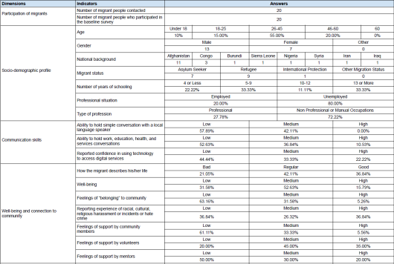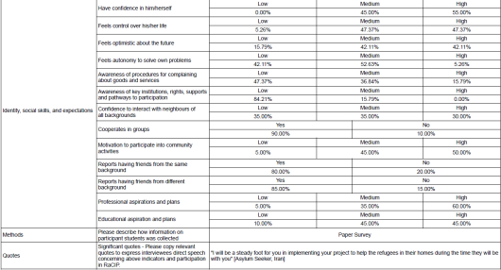

Second Tree - Matrix Students
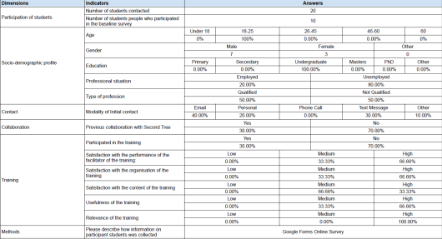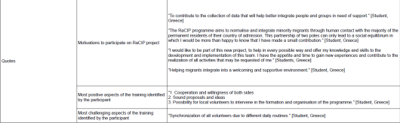

Second Tree - Matrix Families
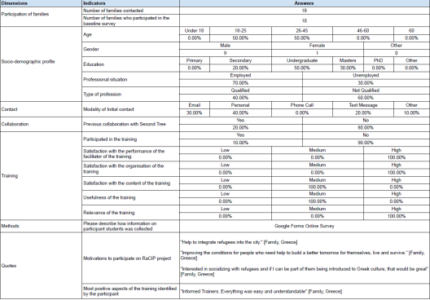

The MoI - Stakeholders
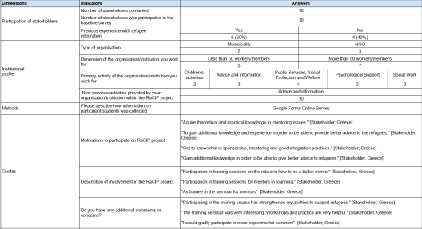
4. Concluding remarks
4.1 Please provide your own reflection regarding how the gender dimension was present/absent in the actions and activities, and in the evaluation process, at this intermediate stage.
Second Tree
During the upcoming activities the gender dimension will not be directly present because the activities will be chosen based on the interest of the participants. The interest of the participants may differ by gender; however, this will not necessarily be the case. This also applies to the pairing of mentors and mentees, which will not be done based on gender. Although if participants prefer, gender-based pairing may occur.
During the evaluation process there was no specific emphasis on gender dimension. The gender balance of the baseline survey participants is as follow:
- Migrants: 65% male vs. 35% female
- Mentors (students and families): 80% male vs 20% female.
The MoI
A total of 31 individuals applied for the stakeholder training course, of which 25 (80%) of the participants were women and 6 (20%) males. This indicates an overwhelming interest of women participating in the training course.

4.2 Please provide other insights and highlights about overall forced migrants and organisations needs and integration conditions. Include discussion points and comments.

Integration into local society is difficult for refugees living in Ioannina urban area, and in Katsikas and Agia Eleni refugee camps. There are several factors hampering integration. First, both camps are located on the outskirts of Ioannina, away from the city centre, secluded from the local community. Bus stations are far away from the camps, and since the start of the COVID-19 pandemic, free transportation has been removed by the government, making travelling into the city unaffordable for many refugees. Second, the lack of Greek language facilities offered to adults hamper integration within the local community. Refugees who live in the city and receive support from the housing scheme named HELIOS need to follow mandatory 3-hour Greek classes five days a week for a period of six months (IOM, 2022b). This obligatory time commitment can be difficult for HELIOS recipients considering that for some the classes need to be combined with a fulltime job. This leaves little time for social activities within the host community.
Third, since spring 2022, a three-metre iron and concrete wall has been built around Katsikas refugee camp. Additionally, a curfew was announced by the camp manager, which is supposed to be a security measure to control the resident’s movement in and outside camp (O’Keeffe, 2022). While the curfew is not enforced yet, the strict security measures increase segregation from the local community.

Bibliography
International Organization for Migration. (2022a). Supporting the Greek Authorities in Managing the National Reception System for Asylum Seekers and Vulnerable Migrants (SMS)— Factsheets (p. 27).
https://www.google.com/url?q=https://greece.iom.int/sites/g/files/tmzbdl1086/files/documents/_merged mainland
march_22_compressed.pdf&sa=D&source=docs&ust=1664388500059640&usg=AOvVaw1 49tp21jrs-w8kQcxd8Fk7
International Organization for Migration. (2022b). Project regulations handbook for beneficiaries of international | IOM Greece. https://greece.iom.int/resources/project regulations-handbook-beneficiaries-international-protection
O’Keeffe, R. (2022, February 2). ‘Please don’t treat us like prisoners’ – refugees react to walls around Greek camps. Synelefsi. https://www.synelefsi.org/post/please-don-t-treat-us-like prisoners-refugees-react-to-walls-around-greek-camps
Refugee Support Aegean. (2022, September 1). The Greek asylum procedure in the first half of 2022. R.S.A. https://rsaegean.org/en/the-greek-asylum-procedure-in-the-first-half-of 2022/
Tramountanis, A., Linardis, A., Mouriki, A., Gerakopoulou, P., Kondyli, D., Papaliou, O., Varouxi, C., & Levine, S. (2022). Humanitarian assistance and social protection responses to the forcibly displaced in Greece.
United Nations High Commissioner for Refugees. (2022, August 17). UNHCR Greece mid-year factsheet 2022. UNHCR Operational Data Portal (ODP).
https://data.unhcr.org/en/documents/details/94932

